

**INFORMATION SCIENCE AND ENGINEERING**

**INTERNET OF THINGS (21ISE47A)**

**Practical Activity**

**CERTIFICATE**

This is to certify that a **Practical Activity** entitled “ Led Lighting On Beat Boxing ” is being

Submitted By

M. SHIVANI KASHYAP (1NH21IS083)

MADHUMITHA A (1NH21IS085)

MOUNIKA S (1NH21IS096)

NAMRATHA S (1NH21IS097)

**Signature of the faculty Dr.**

**T N CHITTI**

(Associate Professor)

**ABSTRACT**

This project enhances the user’s music listening experience by not only adding but also synchronizing visuals to the music. The project digitally analyzes music being played back and controls LEDs to give an audio-visual experience. This report describes the materials and knowledge used to create a proof of concept for a wireless and portable music reactive LED lighting system.

The user provides the music with the help of speakers or with the help of sounds like professional beatboxing and thus making the led light up.

It is a nonlinear format of music that can react to the listener and her /his environment in the real time. The project enhances the user’s music skills by not only adding but also synchronizing visuals to the music. Sensor (ESP8266)

**TABLE OF CONTENTS**

|  |  |
| --- | --- |
| **CONTENTS** | **PAGE NUMBER** |
| **ABSTRACT** | **1** |
| **LIST OF FIGURES** | **3** |
| **LIST OF SCREENSHOTS** | **4** |
| **1. INTRODUCTION** | **5** |
| **2. REQUIREMENTS** |  |
| **2.1 Hardware Components** | **6** |
| **2.2 Software Components** | **7** |
| **3.METHODOLOGY** | **8** |
| **4. IMPLEMENTATION** | **9-10** |
| **5. RESULTS** | **11** |
| **6. CONCLUSION** | **12** |

**LIST OF FIGURES**

|  |  |  |
| --- | --- | --- |
| **Figure No.** | **Particulars** | **Page No.** |
| 1 | Arduino Uno | 4 |
| 2 | Complete Setup | 4 |
| 3 | Sound Sensors | 4 |
| 4 | Arduino Board | 6 |
| 5 | Sound sensor | 6 |
| 6 | Data cable | 7 |
| 7 | Bread Board | 7 |
| 8 | Arduino Logo | 7 |
| 9 | Flowchart | 8 |
| 10 | Connected circuit | 9 |
| 11 | Circuit diagram | 9 |

**LIST OF SCREENSHOTS**

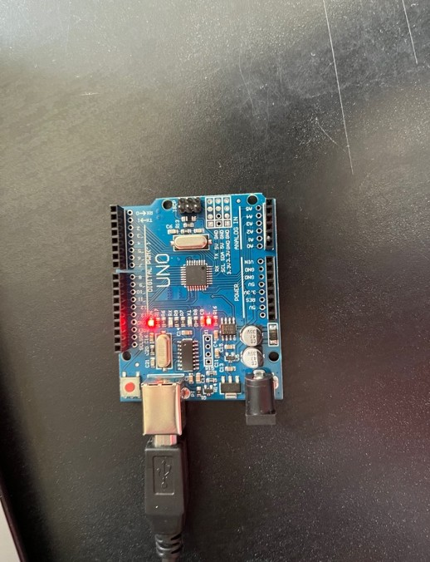

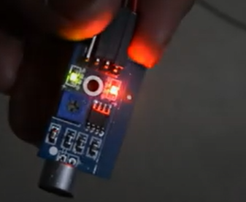

FIGURE 1 FIGURE 2

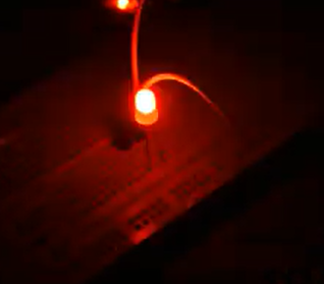

FIGURE 3

**INTRODUCTION**

* Sound sensors are essential devices in various applications, including industrial automation, robotics, automotive systems, and sports analytics.
* The objective of this project is to develop a cost-effective beatboxing reactive led using Arduino and an ESP8266 sensor, capable of accurately measuring the sound or beats of sound whenever the sound/beats is provided.
* The Led glows whenever the music or beats are provided, it is based on the frequency in which we use map(),where the frequency is mapped and the sensor detects the sound/frequency and thus led glows.
* When you make the sound near the mic then the output values start increasing and the Led’s glow as though are providing sounds act as DJ and the led acts as the people reacting towards it.
* The Led lights based on the frequency, if sound provided is more led lights brighter if not then the led becomes low or less brighter.

**REQUIREMENTS**

* 1. HARDWARE COMPONENTS
     + 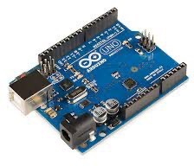Arduino Board: An Arduino UNO or similar microcontroller with sufficient digital input/output (I/O) pins.

FIGURE NO 4

* + - Sound Sensor: One type of module used to notice the sound. Generally, this module is used to detect the intensity of sound based on the input provided. Sound Sensor (ESP8266)

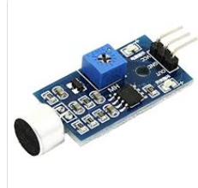

FIGURE NO 5

* Jumper wires: A set of jumper wires for connection
  + - Data cable: A cable to connect the Arduino with the PC

FIGURE NO 6

* + - Bread Board: To place the sensors

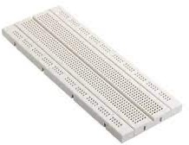

* 1. SOFTWARE COMPONENTS

FIGURE NO 7

* + - A Computer which contains Arduino IDE software present in it.

FIGURE NO 8

METHODOLOGY

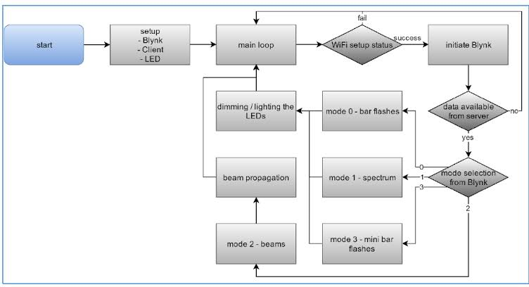

IMPLEMENTATION

**SYSTEM SETUP**:

The Sound sensor relates to respective ports of VCC to the power supply, GND to the ground of Arduino uno board and the A0 pin, the analog pin to the pin specified in the code. Then the led id connected to the respective pin.

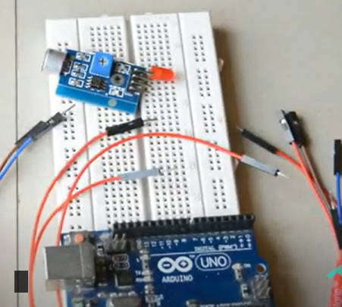

**WORKING PRINCIPLE**:

The sensor detects the sound from the user or the speaker and since the frequency is mapped the led glows and thus the intensity of light is high when the led is on and when the intensity is low the led is low and glows less, thus we play sounds having beats since it has high frequency and thus looks like a DJ box.

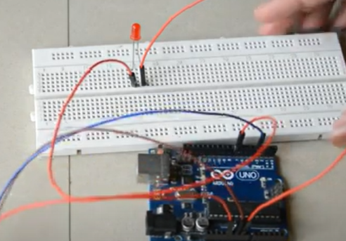

SOURCE CODE

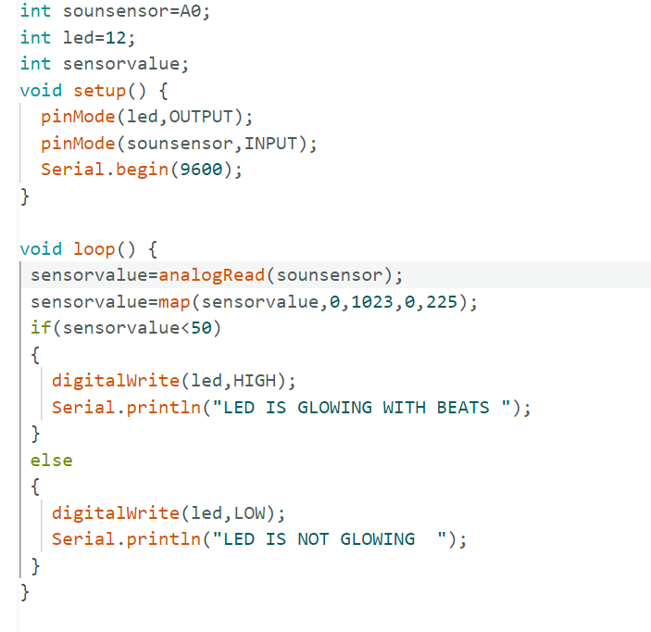

RESULT

A music reactive sensor could be a device that detects audio signals (music, sound effects, spoken words) and translates them into some kind of reactive behavior. Here are a few possible results or outcomes of using a music reactive sensor:

* **Light Display:** A common application of music reactive sensors is creating dynamic light displays that change color, intensity, or patterns based on the music being played. The sensor analyzes the audio input, identifies different frequencies, or beats, and adjusts the lighting accordingly, creating a visually captivating experience.
* **Motion or Movement:** A music reactive sensor could trigger mechanical movements or motions in response to specific audio cues. For example, it could make objects rotate, bounce, or sway in time with the music, adding a kinetic dimension to the auditory experience.
* **Data Visualization:** Music reactive sensors can be used to generate data visualizations that represent various aspects of the audio input. This could involve creating real-time graphs, animations, or other visual representations that provide insights into the audio's characteristics, such as frequency distribution or amplitude changes.
* **Interactive Installations:** Music reactive sensors can be integrated into interactive installations, where the audience's engagement with the music directly influences the sensor's response. This could include touch-sensitive panels that trigger audio-reactive effects or objects that change their behavior based on the proximity or movement of people.

CONCLUSION

Music-reactive LEDs represent an exciting fusion of technology and artistic expression. By synchronizing lights with the rhythm and intensity of music, these LEDs create captivating visual displays that enhance the overall sensory experience. Whether used in live performances, parties, or home entertainment setups, music-reactive LEDs have the power to elevate the atmosphere, engage the audience, and deepen the emotional impact of the music being played.

The technology behind music-reactive LEDs involves the integration of sound analysis algorithms and advanced control systems. These LEDs are able to detect various frequencies, amplitudes, and patterns in the music, translating these audio cues into mesmerizing light patterns that dance and pulse in harmony with the auditory experience.

Moreover, music-reactive LEDs have the potential to inspire creativity and innovation across different domains. Artists, designers, and technologists can collaborate to explore new ways of blending visual and auditory elements, pushing the boundaries of traditional performances and interactive installations. This technology opens avenues for experimentation, encouraging individuals to experiment with lighting design, programming, and real-time synchronization to create unforgettable moments of awe and wonder.

As we continue to advance in the realms of both music and technology, music-reactive LEDs stand as a testament to human ingenuity and the limitless possibilities of human expression. By combining the timeless power of music with cutting-edge illumination, we forge connections between art forms and create shared experiences that transcend cultural, linguistic, and geographical boundaries. Music-reactive LEDs not only entertain and engage, but also serve as a bridge between creativity and innovation, enriching our lives and igniting our imaginations in ways previously unexplored.

FUTURE APPLICATIONS

## The future holds a wide range of exciting and innovative applications for music-reactive LEDs, extending beyond their current uses in entertainment and artistic expression. Here are some potential future applications:

## **Immersive Virtual Reality (VR) and Augmented Reality (AR) Experiences:** Music-reactive LEDs can enhance virtual and augmented reality environments by synchronizing the visual effects with the audio elements. This could lead to more immersive and captivating experiences in gaming, education, training simulations, and other interactive applications.

## **Wellness and Therapy:** Music-reactive LEDs could find applications in wellness and therapy settings. For example, they could be integrated into meditation spaces, relaxation rooms, or sensory therapy environments to create calming and visually engaging atmospheres that align with soothing music or soundscapes.

## **Smart Home Integration:** With the rise of smart home technology, music-reactive LEDs could be integrated into lighting systems to respond to music played in the home environment. This would enable homeowners to create dynamic lighting displays that complement their music listening experience and set the mood for various occasions.